Chapter 10, Solution 69.

For the differentiator shown in Fig. 10.112, obtain V_{o}/V_{s}. Find v_{o}(t) when
v_{s}(t) = V_{m} sinω t and ω = 1/RC.

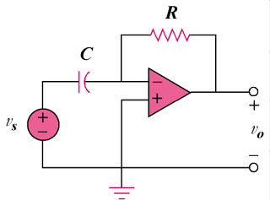

Figure 10.112
For Prob. 10.69.

Solution

This is an inverting op amp so that
–jωRC

When and ,

Therefore,

V_{m} sin(ωt – 90°) = –V_{m} cos(t)

